

ISSC AS Learning
Organizational Training Program DB
V1.1

Employee User’s Guide

IBM China Global Delivery
Application Service

Author: ISSC AS Competency
Last Update: Feb 2007

Total Pages: 13

About this document
Produced using Microsoft Word 2000
Filename:
Template Version:
Revision History
Version | Date | Author | Change Description
1.0 | 2006-12-27 | Feng Min | Initial version
1.1 | 2007-02-07 | Feng Min | Added Group Information in certification DB part  Added Competency admin information in enroll DB part

Reviewer
This document requires the following signed reviewer:
Name | Title | Signature
Mei Jie | Skill Team Leader | Mei Jie

Table of Contents

Certification DB 3
Introduction 3
End User Key Function Introduction 3
How to access Certification DB 3
How to register your Certification in DB 4
Registration Reference by Certification Type 5
[Reference] Group Information in Certification DB 6
Training Enroll DB 8
Introduction 8
How to access Training Enroll DB 8
How to enroll class/test/booking CD in Training Enroll DB 8
How to get help from competency team 10
Training DB 11
Introduction 11
How to access Training DB 11

Certification DB

Introduction
Certification DB is a notes based DB that allows ISSC AS employees who possess certificates to use this tool to register their certification information.
Three kinds of certification are identified:
- Technical
- Language
- Professional
As ISSC AS Regular employee, you are requested to do
- Mandatory action to register your certification in certification DB
- Update your certification information timely in certification DB
- Register your new certification in certification DB

End User Key Function Introduction
Below are the key functions for end user in certification DB:
- Automatically load Personal information: the personal information can be loaded from bluepage into certification DB automatically, such as S/N, Notes id, Manager Information
- Re-defined the Certification Category: end user can select the certification accordingly, if no proper category, please select 'Others’, the user can input the certification
- Unique Registration: the certification registration should be unique, the user should register the same certification with the highest score, for example: you took TOEIC test twice, if you got higher point in the 2nd test, so you only need to register TOEIC this 1 certification with the highest score. [Action: update the score based on the last registration].
- Multi-view Function: the certification record from DB can be sorted by Reporting manager/Employee Name/Organization/Location
- Authorization control: Manager can get his/her DR's certification record, but employees only can see their own record

How to access Certification DB
- From the Lotus Notes workspace, select File-Database-Open from the pull down menu.
- Type in "ETCDOM01/IBMSHETC" in the Server selection box.
- Type in “ISSC\Competency\Certification.nsf" in the Filename selection box and click "Open".
- You will be taken directly into the Help-About document of the database and the icon will have been added to your workspace.

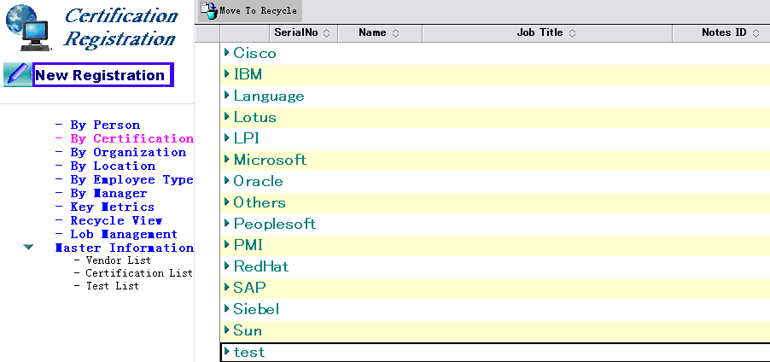

How to register your Certification in DB

1. Click the button New Registration at the left upper corner.
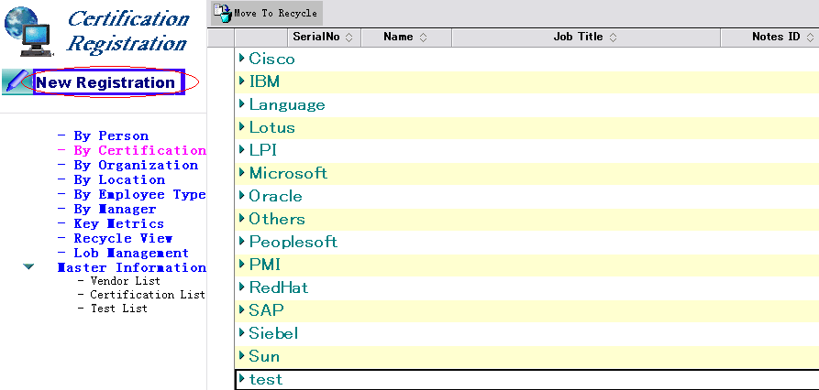

2. Type in the personal info, certification category and relevant test info in the Registration form (shown as below).

Please be attention to the consistence of certificate acquired and test passed.

Click ’Save’ to complete your registration.
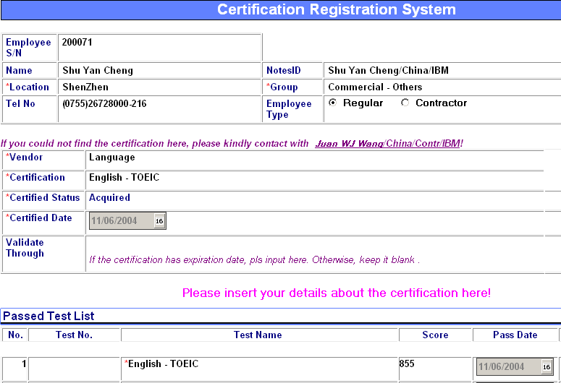

Registration Reference by Certification Type

1. Language Certification
- Register English language certificate such as
- TOEIC ,TOEFL ,IELTS
Please register your certificate and also the score if you have passed TOEIC >=730
Or TOEFL >= 580 or IELTS >= 6.0. For TOEIC/TOEFL/IELTS, score input is required.

- CET-4 and CET-6 certificate
Most employees have CET-4 or CET-6’s certificate, so please register your
CET-6/CET-4 at once!
To better consolidate these CET certificates, please register the highest one only.
For example, if you have two certificates (both of CET-4 and CET-6), then
Please register CET-6 only.

- Register Japanese language certificate such as
- JLPT-1/-2/-3 or Jtest-A/-B/-C/-D/-E

Please select highest level certificate to register (JTest and JLPT has equivalent relationship).
For JTest, score input is required.

For example1, if you have two certificates (both of JLPT-1 and JLPT-2),then please register JLPT-1 only.
For example2, if you have two certificates (both of JLPT-1 and JTest B scoring), then please register JLPT-1 only.

Reference--JLPT and J-test Equivalence
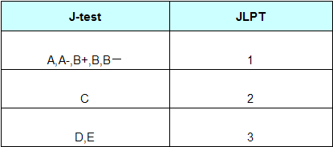
2. Professional Certification
- PMP
If you have passed PMP exam, please register it in certification DB.

3. Technical Certification
Such as Cisco, DB2, WebSphere, XML, Lotus Notes, Oracle, Java...
Any technical certificates within our list in DB are allowed to register. Especially for those passed SWG test, your registration in the certification DB is the prerequisite for the test fee reimbursement.

[Reference] Group Information in Certification DB

Currently, we have 9 groups in certification DB. DB will extract your group information automatically.

- SH JP Commercial
- DL JP Commercial
- JP-IGA
- Finance Sector
- US Commercial
- Non-JP IGA
- Domestic
- Competency
- Non-AS

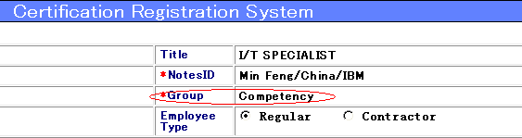

Training Enroll DB

Introduction
The Training Enroll DB is a notes based DB that allows ISSC AS regular employees who want to attend ISSC AS internal training class/Technical or Language test to use this tool to enroll them.

These courses which are loaded in Enroll DB are based on ISSC AS Organizational Training plan.

How to access Training Enroll DB
- From the Lotus Notes workspace, select File-Database-Open from the pull down menu.
- Type in "ETCDOM01/IBMSHETC" in the Server selection box.
- Type in “ISSC\Competcy\IsscCourseEnroll.nsf" in the Filename selection box and click "Open".
- You will be taken directly into the Help-About document of the database and the icon will have been added to your workspace
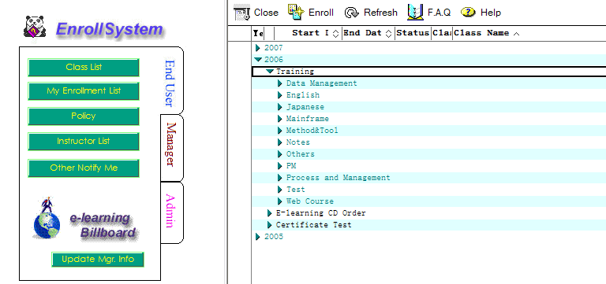

How to enroll class/test/booking CD in Training Enroll DB
- Enroll Classroom Training/Test

1) If you are a new user of the DB, Please read ‘Policy’ carefully first
2) Select the useful class for you which is listed in enroll DB class list
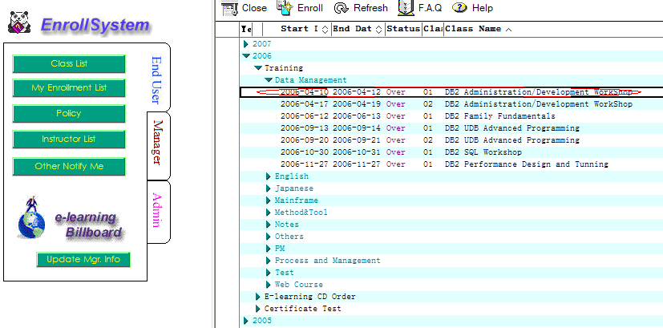
3) Double click the course to get detailed information
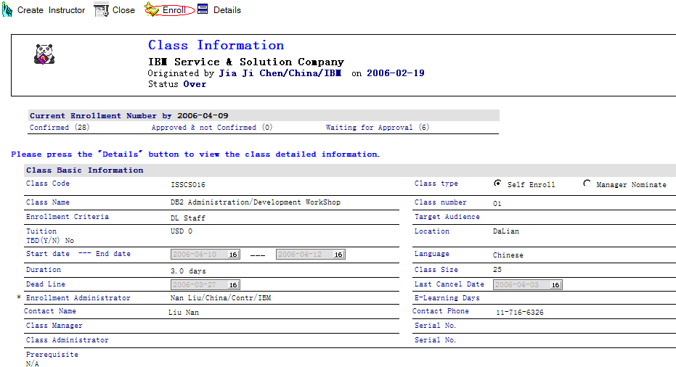
4) Click ‘Enroll’ to enroll this class or test, a note will be sent to your manager for approval as well
5) After you get your manager’s approval notes, you need wait for the Confirmation letter sent by training admin, which is sent according to below criteria:
- We only have very limited seats (25 seats for technical &Japanese class and 16 for English language class) for attendees, so if enrolled more than 25 attendees, generally we take first com first serve rule.
- Please read course information carefully, if you are not the target audience, please do not enroll the class.
- Please read the Enrollment Criteria carefully. If you don’t meet it, your enrollment priority will be lower.
- If the enroll status is ‘Full’, it means the class size is over beyond the max enrollment number, you cannot enroll this course or test any more.

- Booking E-learning CD
You are not allowed to book CD whenever you want. Competency will send out announcement to all regular for CD’s booking, according to the WW learning team direction. Detailed information on how to book CDs, please refer to the Booking CD announcement from competency.
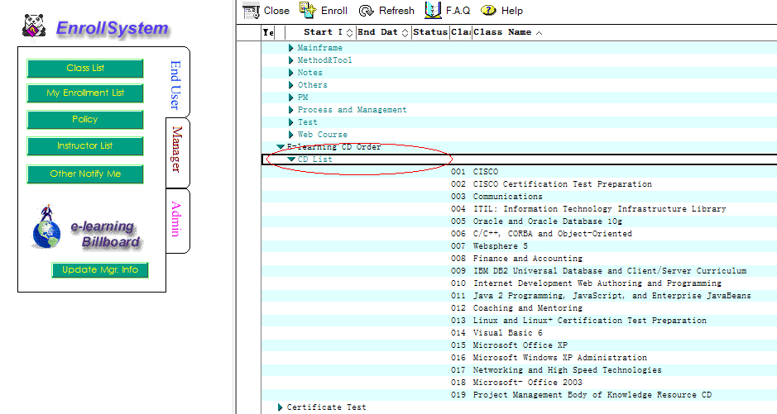

How to get help from competency team

We have 4 competency admins in 4 locations (SZ/SH/DL/CD)

Name | Role | Notes ID
Deng Cui Fen | SZ Skill Admin | Cui Fen Deng/China/Contr/IBM
Brenda Zhang | SH Skill Admin | Brenda L Zhang/China/Contr/IBM
Guan Huan Huan | DL Skill Admin | Huan Huan Guan/China/Contr/IBM
Wang Wen Jia | CD Skill Admin | Wen Jia Wang/China/Contr/IBM

Training DB

Introduction
ISSC AS Training DB is a notes based DB that allows ISSC AS employees who want to get the training information (Training Log/Training plan/Training Roadmap/Miscellaneous Training Policy) to get training related information from it.

How to access Training DB
1. From the Lotus Notes workspace, select File-Database-Open from the pull down menu.
2. Type in "ETCDOM01/IBMSHETC" in the Server selection box.
3. Type in " ISSC\Project\ISSC_Training.nsf" in the Filename selection box and click "Open".
4. You will be taken directly into the Help-About document of the database and the icon will have been added to your workspace

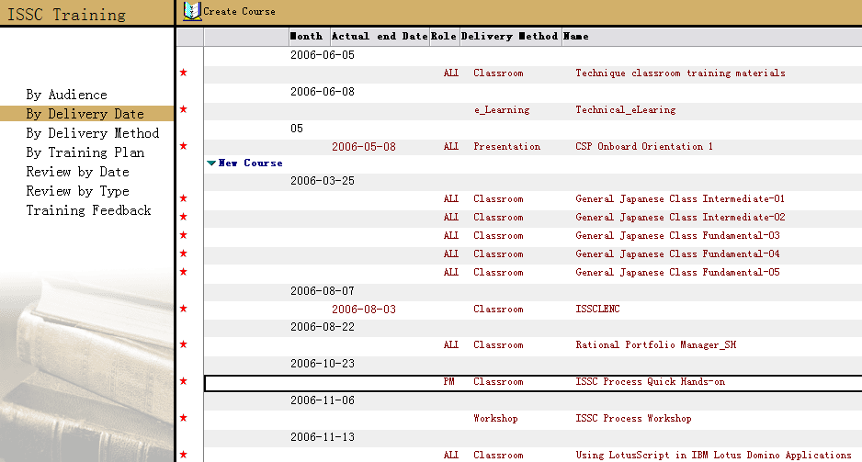

By Delivery Date View: You can get the training log of each class delivered before
By Training Plan View: You can get the latest Organizational Training Program Plan, the Organizational Training Roadmap, as well as other Training related policy announced by AS Competency team before

Please notes:

This DB for employees is Read Only [Only For Reference]
You can get the training information which you want in training DB, you are not allowed to any other higher authority.

----This is the last page---

